IN3005: Computer Graphics using OpenGL Interim Coursework

Name: Wajid Uddin
Student ID: 220028395

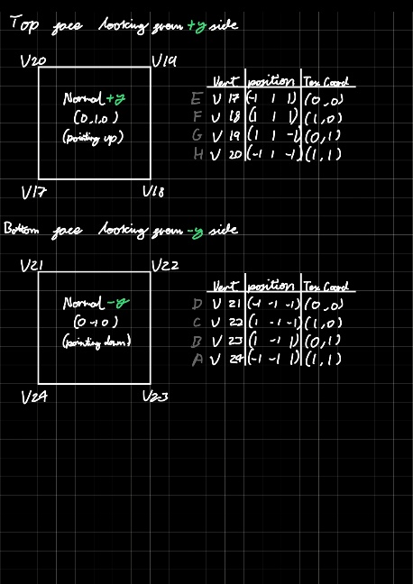
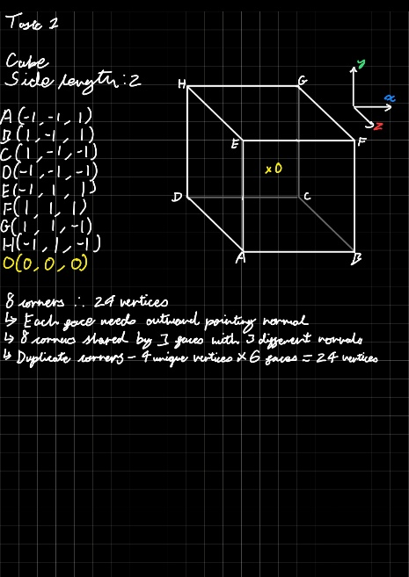
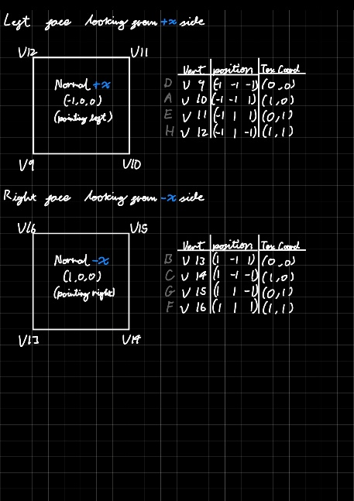
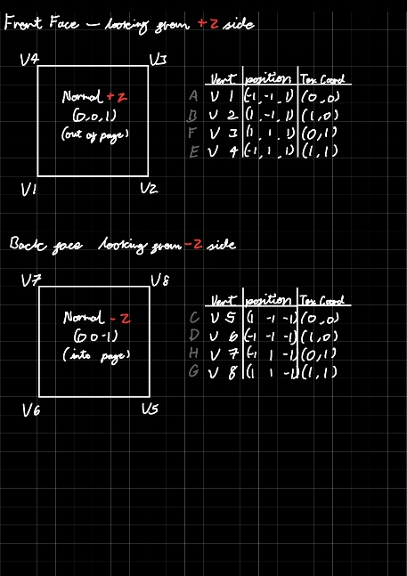
Task 1 – Object definition - geometry, normals, texture coordinates and triangles (15%)
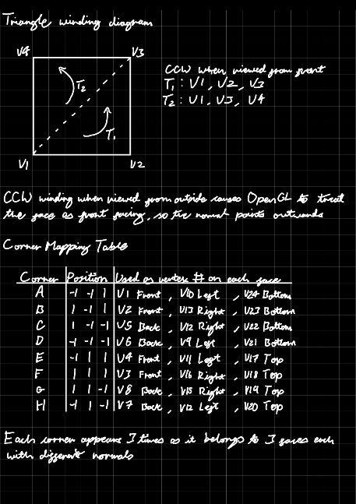
Task 2 – Vertex Buffer Object (VBO) design (15%)
Assuming we do NOT have the helper classes
VBO Layout
Each vertex is stored interleaved in a single buffer in this order:
Attributes | Type | Components | Size (bytes) | Offset (bytes)
Position | Float | 3 (x, y, z) | 12 | 0
Texture Coord | Float | 2 (u, v) | 8 | 12
Normal | Float | 3 (x, y, z) | 12 | 20
Total Stride |  |  | 32
Total VBO: 24 vertices × 32 bytes = 768 bytes
Total IBO: 36 indices × 4 bytes = 144 bytes
OpenGL Calls
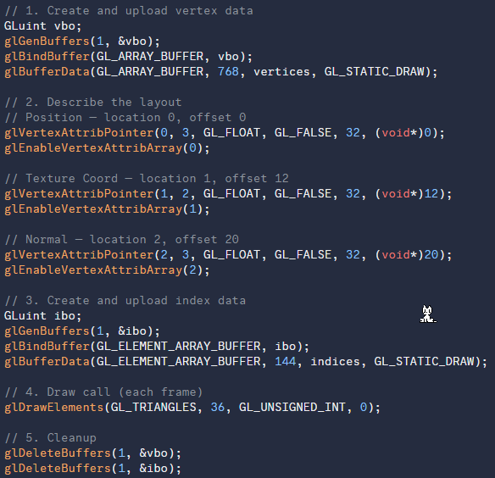
Task 3 – Implementation in the template code (20%)
Creating the Cube Class
Created the Cube class files ‘Cube.h’ and ‘Cube.cpp’ from a copy of the Sphere class. Has the same methods ‘Create()’, ‘Render()’, and ‘Release’.
Create Function
The ‘Create()’ function was reimplemented to define the 24 vertices of the cube in interleaved format (Position, Texture Coordinate, Normal). The vertex and index data is added using the template's ‘CVertexBufferObjectIndexed’ helper class, then uploaded to the GPU:
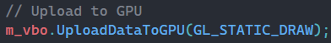
The attribute pointers are then set with the correct stride (32 bytes) and offsets: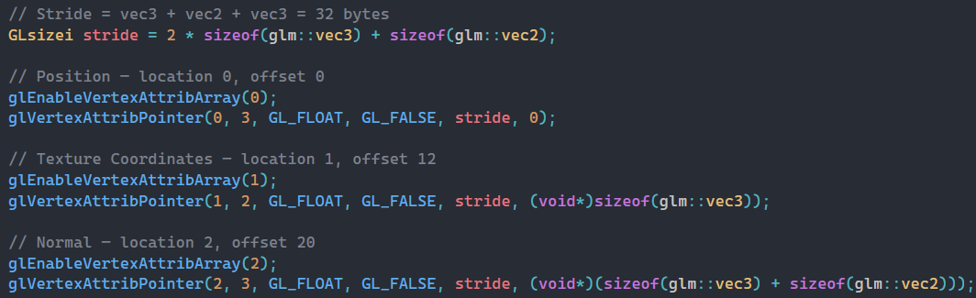
Render and Release
The ‘Render()’ function binds the VAO, binds the texture, and draws the 36 indices as triangles:
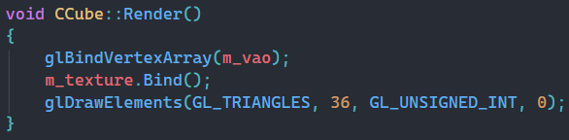
The ‘Release()’ function deletes the texture, VAO, and VBO from the GPU.
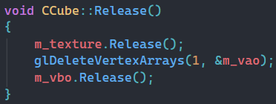

Integration in Game.cpp
- #include “Cube.h” added at the top
- CCube *m_pCube declared as a member in Game.h
- m_pCube initialised to NULL in the constructor
m_pCube = new CCube and m_pCube->Create(...) called in Game::Initialise()
- m_pCube->Render() called inside the render loop in Game::Render()
- delete m_pCube added to the destructor
The cube is placed at (25.0f, 5.0f, 100.0f), approximately to the left of the camera. Renders using existing ‘mainShader’.

Task 4 – Shader implementation (20%)
Shader program ‘cubeShader.vert’ / ’cubeShader.frag’ created for the cube and loaded as a separate ‘CShaderProgram’
Vertex Shader
The vertex shader transforms each vertex to clip space and passes the eye-space normal and position to the fragment shader for per-fragment lighting: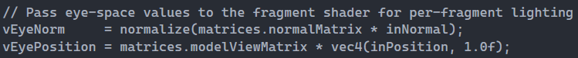
Fragment Shader
Lighting is calculated per fragment using the Phong reflectance model, which produces sharper and more accurate specular highlights than the per-vertex Gouraud shading used in `mainShader`:
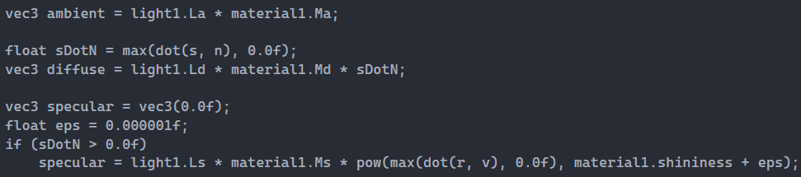
Material Properties
The cube uses custom material values to make the shading more visible

Task 5 – Camera positioning (10%)
Path Definition
Four control points defined around the cube at world position `(25, 5, 100)`, forming a closed circular orbit at height `y = 30` with a radius of 30 units:
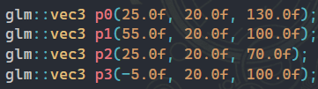
Camera Movement
To achieve a full closed loop, `m_t` is mapped across all 4 segments by multiplying by 4 and using modulo to select the correct segment and wrap back to `p0` after `p3`:
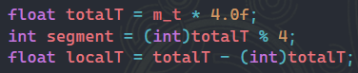
The camera position is then sampled from the current segment:
Camera Orientation
camera always looks directly at the cube's world position:
Task 6 - Texture mapping (10%)

Task 7 – OBJ Format (10%)
The cube.obj and cube.mtl files were written manually using the vertex data calculated in Task 1.
The OBJ file contains 24 vertex positions, 4 texture coordinates, 6 normals and 12 faces. Vertices are duplicated per face so each face has its own outward-pointing normal. Faces are listed in CCW winding order in the format ‘v/vt/vn’.
The MTL file defines a single material with a mid-grey diffuse colour, a small specular value, and references ‘dirtpile01.jpg’ as the texture via ‘map_Kd’.
Both files can be found in resources/models/Cube.

